

**2023**



|  |  |  |
| --- | --- | --- |
| Supervisor | Sir Aqeel | |
| Batch | **PR2-20229C1** | |
| Group | **C** | |
| Serial No. | **Enrollment Number** | **Student’s Name** |
| 1. | Student1416826 | Anees |
| 2. | Student1415380 | Messum |
| 3. | Student---- | Hassan |

**Table of Content**

# **Certificate of Completion**

This is to certify that  **Anees, Messum, Hassan** have successfully completed their ACCP Prime 2.0

Semester II E-Project.

Submitted to: **Aptech Computer Education**

On

**Oct 01th, 2023**

# **Acknowledgement**

First of all we would like to thank **Almighty Allah** for giving us strength and ability to complete this project.

And then, we would like to express my special thanks of gratitude to our teacher **Sir Aqeel** who guided us on the project ***Online Shopping Card***, which also helped us in doing a lot of new learning and we came to know about so many new things we are really thankful to him.

We are highly thankful to **Sir Aqeel** for his guidance and constant supervision as well as for his support in completing the project.

Lastly, we would also like to thank our parents and friends who helped us a lot in finalizing this project within the limited time frame. We also express our sincere gratitude to I-Project team from Aptech Head Office, for their valuable guidance and support for the completion of this project. We earnestly hope that this project will provide all the necessary information required by the user to fulfill his/her inspiration. However, suggestion and Feedbacks for improvements will be thankfully welcomed & acknowledged*.*

# **Problems Statement:**

Venus Handicrafts is certified company engaged in manufacturing and exporting of Decorative Handicrafts to global importers, wholesalers and retailers since 1972. The ever-increasing acceptance of our products on global platform highlights our market presence and goodwill. The company has maintained its market value throughout the world. To enhance its value the organization wants to change the look and feel of the website for which they have approached you.

# **Functional Specification**

# The Web site is to be created based on the following requirements.

1) Gifts

2) Paper Work

3) Purses

4) Fashion

5) Dolls

6) FAQs

# **Hardware and Software Requirements**

**Hardware**

* A minimum computer system that will help you access all the tools in the courses is a Pentium
* 64 Megabytes of RAM or better

**Software**

* Notepad/HTML editor
* Dreamweave

**USER’S GUIDE**

HOME PAGE:

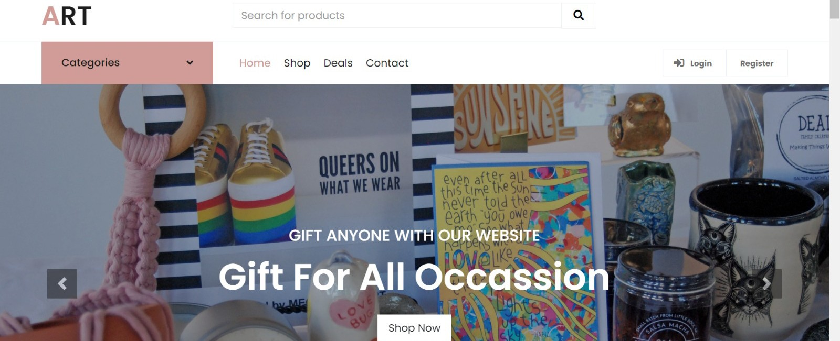

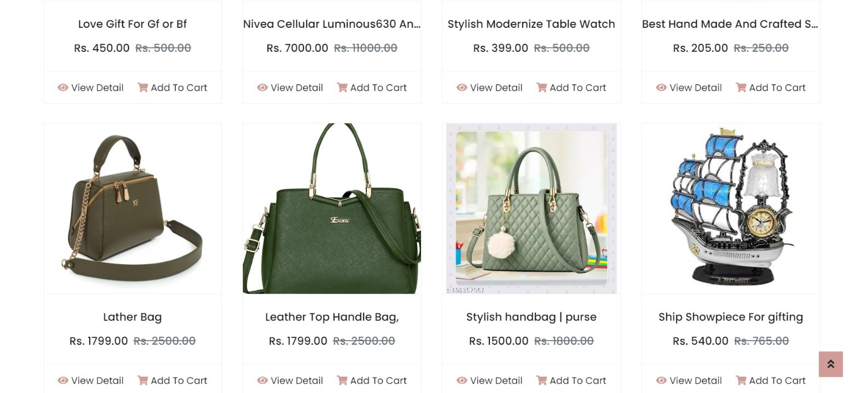

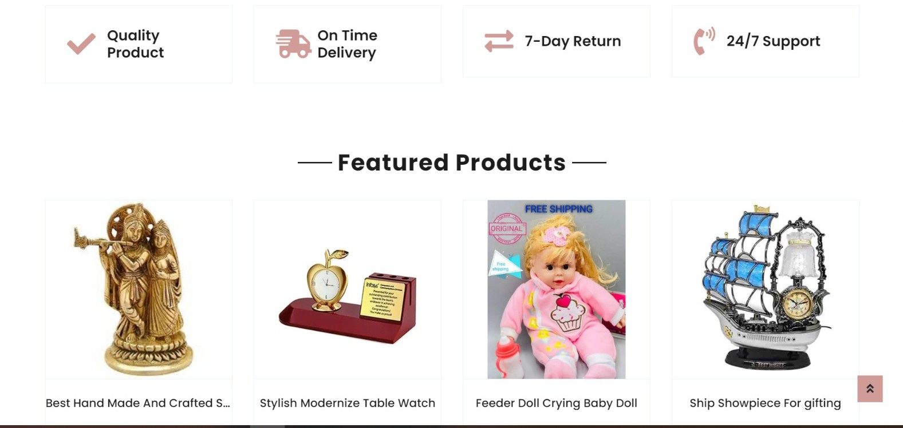

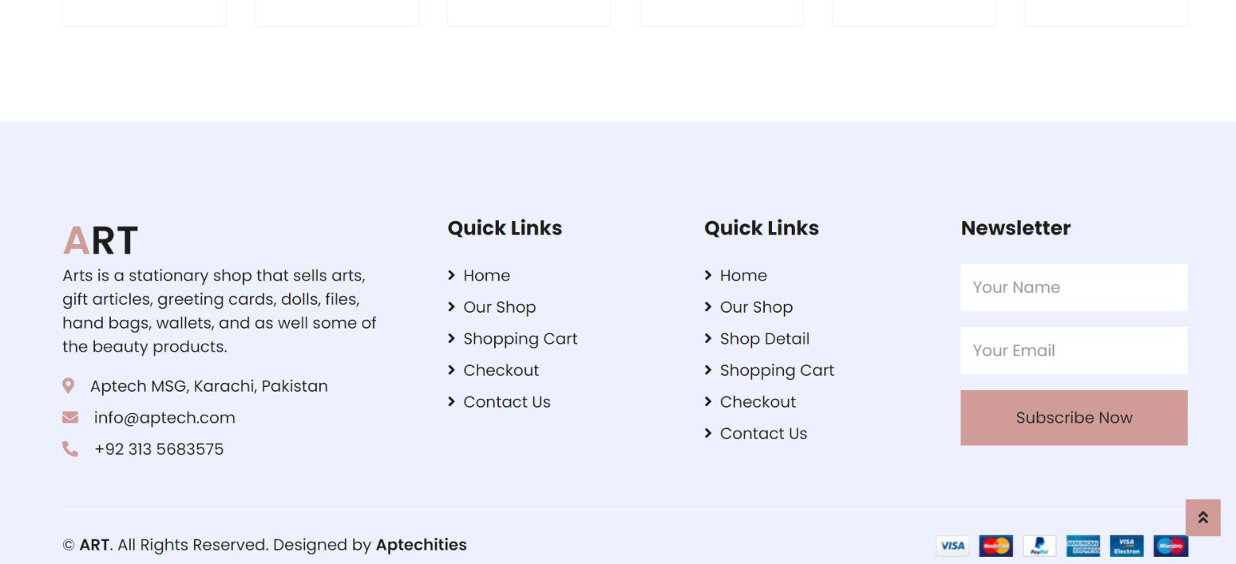

**

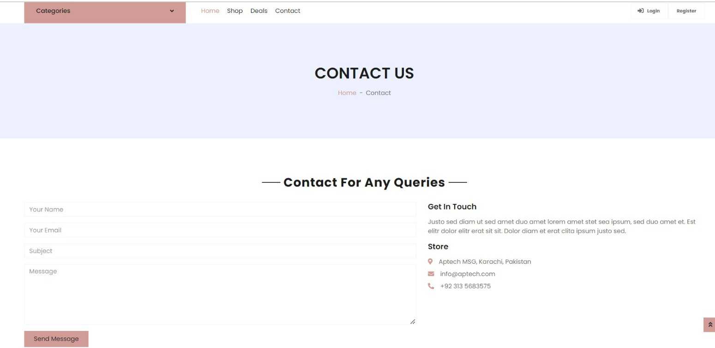

*Footer*

**

**DEVELOPER’S GUIDE:**

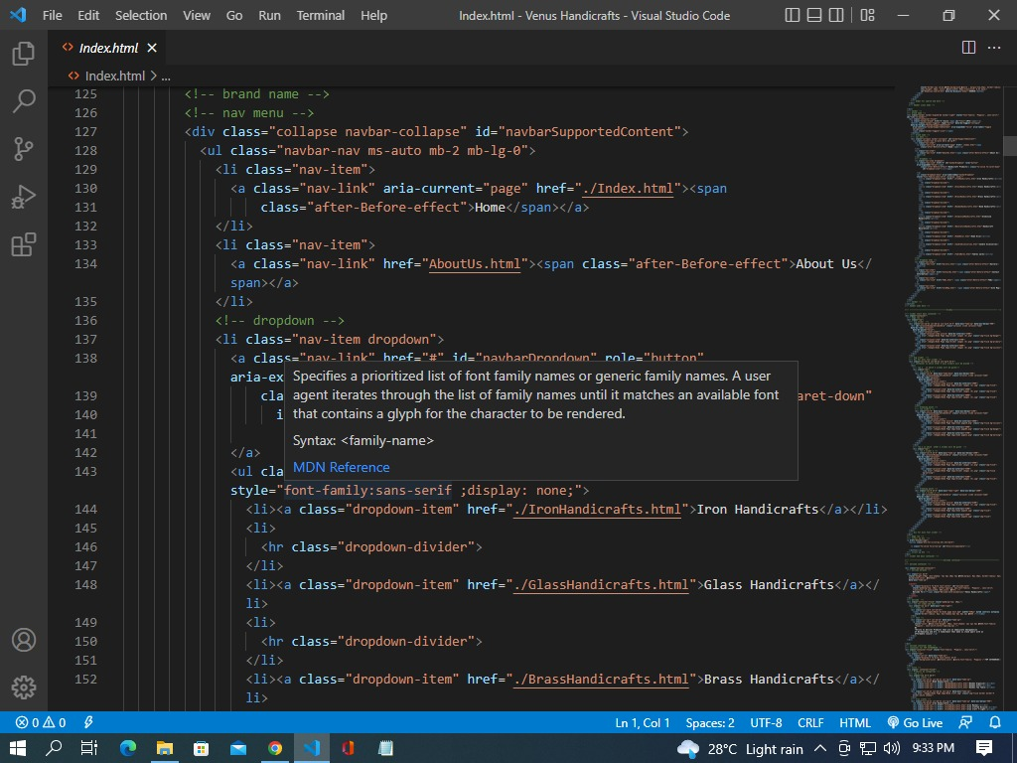Homepage:

SLIDER: 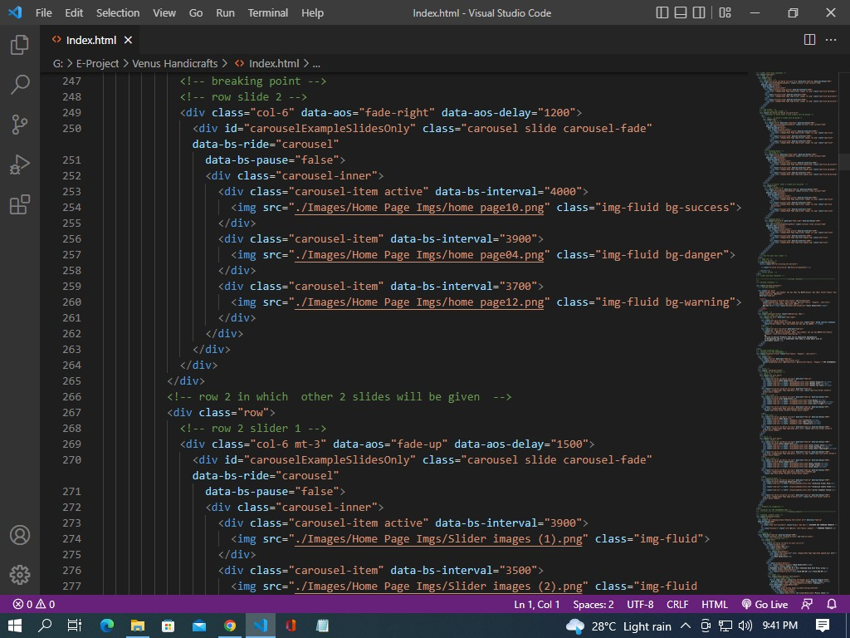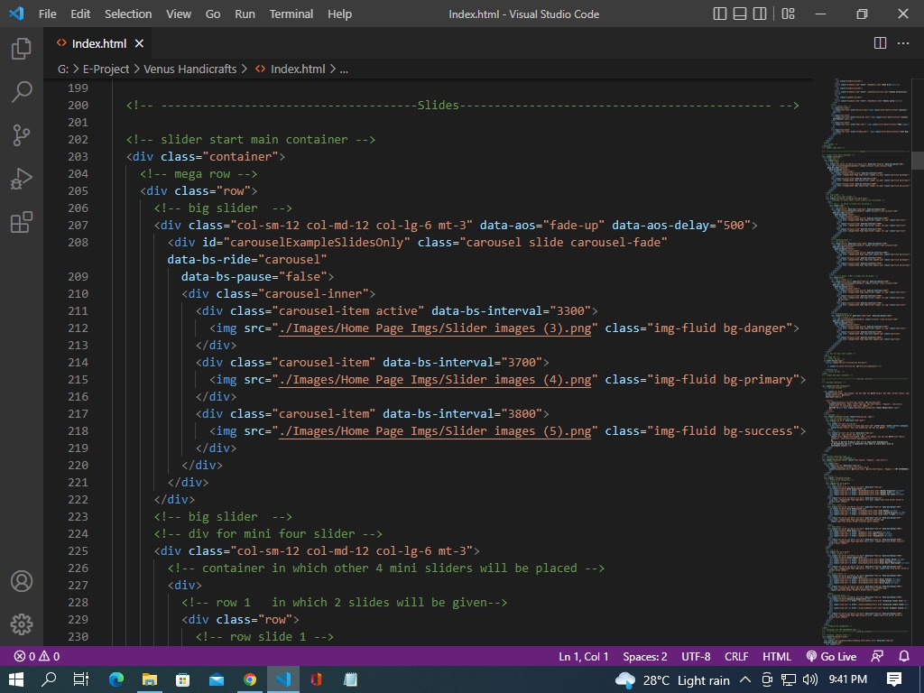

FOOTER:

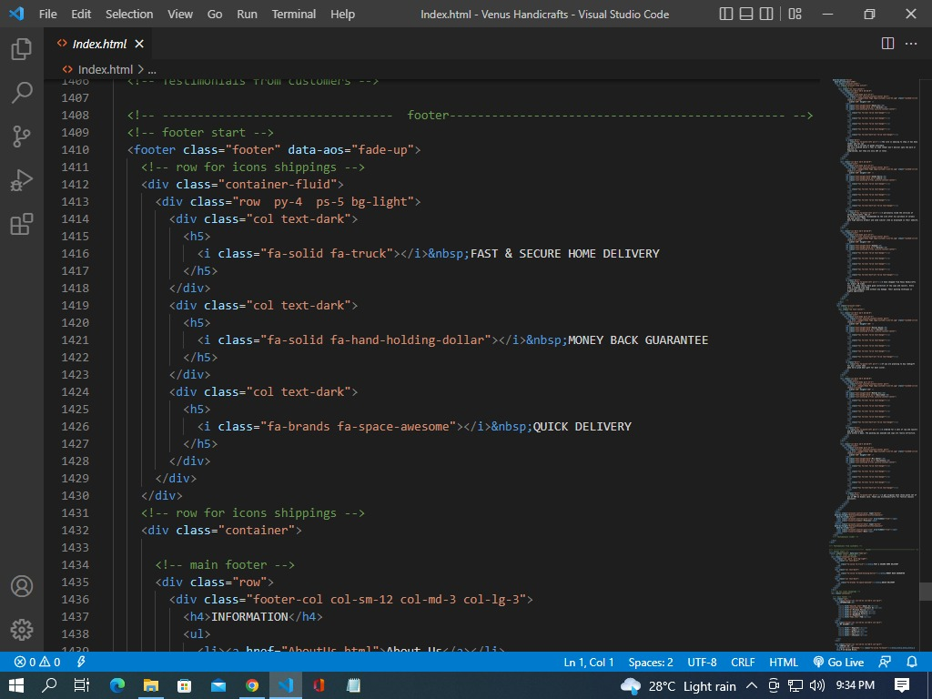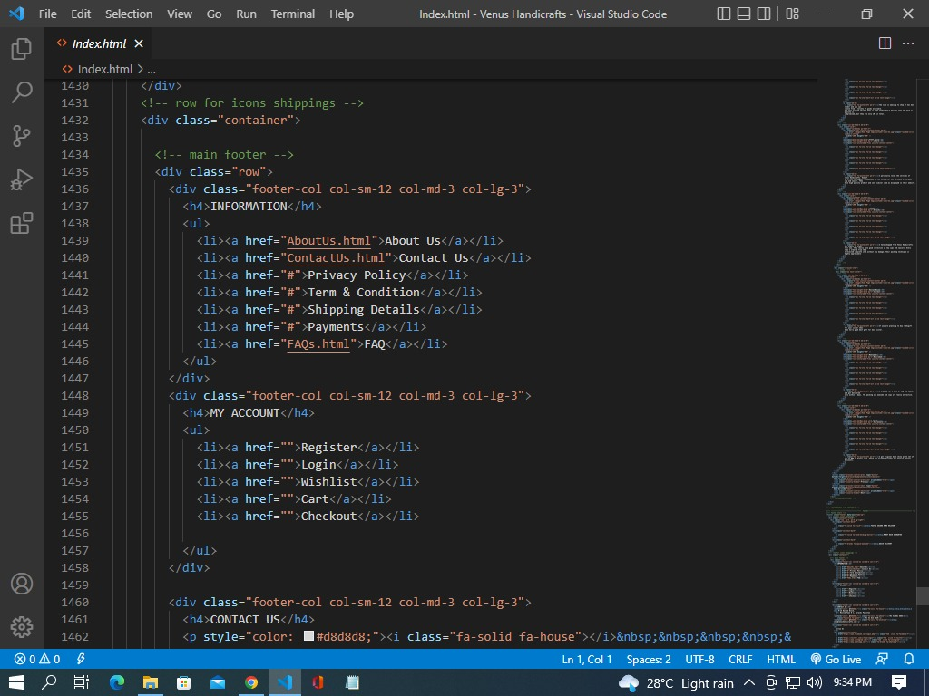

**Task Sheet**

|  |  |  |  |  |
| --- | --- | --- | --- | --- |
| Project Ref. No. | | Project Title | Date of Preparation of Activity Plan | |
| S.No. | Ta | **Online shopping Card** | Actual Days | Status |
| 1 | Analysis | 2 | OK |
| 2 | Design | 4 | OK |
| 3 | Development | 7 | OK |
| 4 | Testing | 1 | OK |
| 5 | Documentation | 1 | OK |